Министерство науки и высшего образования Российской Федерации
Муромский институт (филиал)
Федерального государственного бюджетного образовательного учреждения высшего образования
«Владимирский государственный университет
имени Александра Григорьевича и Николая Григорьевича Столетовых»

Факультет ИТР
Кафедра ПИн

ЛАБОРАТОРНАЯ
РАБОТА №5

По Проектирование человеко-машинного интерфейса
Тема Страничный интерфейс

Руководитель
Каряев В.В.
(фамилия, инициалы)

(подпись) (дата)

Студент ПИн - 121
(группа)
Ермилов М.В.
(фамилия, инициалы)

(подпись) (дата)

Муром 2023
Лабораторная работа №4

Тема: Страничный интерфейс
Цель: Научиться создавать и использовать страничный интерфейс вместо стандартных окон в приложениях WPF.
Задание:
1. Изучить материал, представленный в данных методических указаниях к лабораторной работе, а также материал находящийся в сети интернет в свободном доступе по данной теме; 2. Разработать приложение, согласно заданию преподавателя; 3. Составить отчёт. В отчёте отобразить:  -цели и задачи лабораторной работы;  -исходный код приложения (отображающий только логику программы и описание работы);  -код XAML;  -скриншоты работы приложения; -выводы по данной лабораторной работе.
Листинг программы:
using System.Windows.Navigation;
namespace FifthExample
{
public partial class MainWindow : NavigationWindow
{
public MainWindow()
{
InitializeComponent();
}
}
}

using System.Windows;
using System.Windows.Controls;
namespace FifthExample
{
public partial class Home : Page
{
public Home()
{
InitializeComponent();
}
private void Button_Click(object sender, RoutedEventArgs e)
{
Report reportPage = new Report(this.lbPeople.SelectedItem);
this.NavigationService.Navigate(reportPage);
}
}
}
Листинг кода 3 - Report.xaml.cs:
using System.Windows.Controls;
namespace FifthExample
{
public partial class Report : Page
{
public Report()
{
InitializeComponent();
}
public Report(object data) : this()
{
lName.Content = data is ListBoxItem ?
(data as ListBoxItem).Content.ToString() : "Ничего";
}
} }

<NavigationWindow x:Class="FifthExample.MainWindow"
xmlns="http://schemas.microsoft.com/winfx/2006/xaml/presentation"
xmlns:x="http://schemas.microsoft.com/winfx/2006/xaml"
Title="Страничное приложение" Height="300" Width="500" MinWidth="500" MinHeight="300"
Source="Home.xaml">

<Page x:Class="FifthExample.Home"
xmlns="http://schemas.microsoft.com/winfx/2006/xaml/presentation"
xmlns:x="http://schemas.microsoft.com/winfx/2006/xaml"
xmlns:mc="http://schemas.openxmlformats.org/markup-compatibility/2006"
xmlns:d="http://schemas.microsoft.com/expression/blend/2008"
mc:Ignorable="d"
d:DesignHeight="300" d:DesignWidth="500"
Title="Home">
<Grid Margin="10,0,10,10">
<Grid.ColumnDefinitions>
<ColumnDefinition />
</Grid.ColumnDefinitions>
<Grid.RowDefinitions>
<RowDefinition Height="Auto"/>
<RowDefinition />
<RowDefinition Height="Auto"/>
</Grid.RowDefinitions>
<Border Grid.Column="0" Grid.Row="0" Height="35" Padding="5" Background="Blue">
<Label VerticalAlignment="Center" Foreground="White">Имена</Label>
</Border>
<ListBox Name="lbPeople" Grid.Column="0" Grid.Row="1">
<ListBoxItem>Андрей</ListBoxItem>
<ListBoxItem>Вася</ListBoxItem>
<ListBoxItem>Илья</ListBoxItem>
<ListBoxItem>Мария</ListBoxItem>
</ListBox>
<Button Grid.Column="0" Grid.Row="2" Margin="0,10,0,0" Width="125" Height="25"
HorizontalAlignment="Right" Click="Button_Click">Показать</Button>
</Grid>
</Page>

<Page x:Class="FifthExample.Report"
xmlns="http://schemas.microsoft.com/winfx/2006/xaml/presentation"
xmlns:x="http://schemas.microsoft.com/winfx/2006/xaml"
xmlns:mc="http://schemas.openxmlformats.org/markup-compatibility/2006"
xmlns:d="http://schemas.microsoft.com/expression/blend/2008"
mc:Ignorable="d"
d:DesignHeight="300" d:DesignWidth="500" Title="Report">
<StackPanel Margin="50">
<Border Height="35" Padding="5" Background="Blue">
<Label Foreground="White" Content="Вы выбрали"/>
</Border>
<Border Height="35" Padding="1" BorderThickness="2" BorderBrush="Blue">
<Label Name="lName" VerticalAlignment="Center"/>
</Border>
</StackPanel>
</Page>
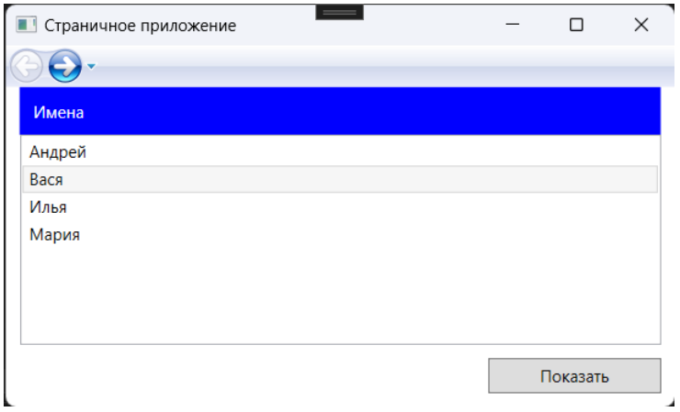
Рисунок 1 - пример работы программы

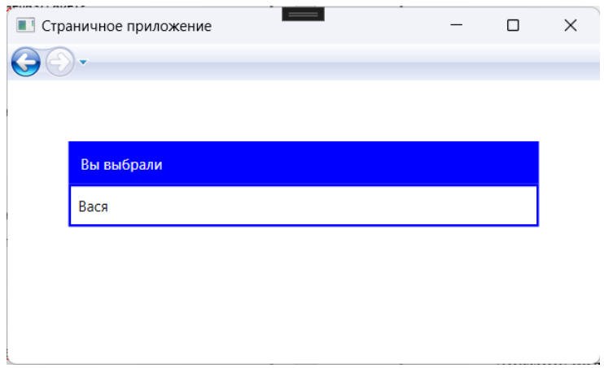
Рисунок 2 - пример работы программы

Листинг программы:
using System.Windows;
using System.Windows.Navigation;

namespace work
{
public partial class MainWindow : NavigationWindow
{
public MainWindow() : this("ru-RU") { }
public MainWindow(string culture)
{
System.Threading.Thread.CurrentThread.CurrentUICulture = System.Globalization.CultureInfo.GetCultureInfo(culture);
InitializeComponent();
}
}
}
<NavigationWindow x:Class="work.MainWindow"
xmlns="http://schemas.microsoft.com/winfx/2006/xaml/presentation"
xmlns:x="http://schemas.microsoft.com/winfx/2006/xaml"
Height="300" Width="500" MinWidth="500" MinHeight="300"
Source="PageList.xaml" ></NavigationWindow>

using Microsoft.Win32;
using Newtonsoft.Json.Linq;
using System;
using System.Collections.Generic;
using System.IO;
using System.Windows;
using System.Windows.Controls;

namespace work
{
public partial class PageList : Page
{
static List<JObject> Book = new List<JObject>();
static string LastFolder = Environment.GetFolderPath(Environment.SpecialFolder.Desktop);
public PageList()
{
InitializeComponent();
WindowTitle = Properties.Resources.ListBook;
foreach(JObject book in Book)
List.Items.Add(book["title"].ToString() + " - " + book["author"].ToString());
}

public void OpenFile(object sender, RoutedEventArgs e)
{
OpenFileDialog dialog = new OpenFileDialog();
dialog.Filter = "json Files (*.json)|*.json|All Files (*.*)|*.*";
dialog.InitialDirectory = LastFolder;
// if (dialog.ShowDialog()) - error
// if ((bool)dialog.ShowDialog()) - warn
// dialog.ShowDialog() -> bool?
if (dialog.ShowDialog() == true)
{
string? lastFolder = Path.GetDirectoryName(dialog.FileName);
if (lastFolder != null)
{
LastFolder = lastFolder;
JObject? book = null;
try
{
book = JObject.Parse(File.ReadAllText(dialog.FileName));
}
catch { }
if(book != null)
if (book.ContainsKey("title") && book["title"].Type == JTokenType.String &&
book.ContainsKey("author") && book["author"].Type == JTokenType.String &&
book.ContainsKey("year") && book["year"].Type == JTokenType.String &&
book.ContainsKey("sections") && book["sections"].Type == JTokenType.Array)
{
Book.Add(book);
List.Items.Add(book["title"] + " - " + book["author"]);
}
else
MessageBox.Show(Properties.Resources.noJSON, Properties.Resources.Error, MessageBoxButton.OK, MessageBoxImage.Error);
else
MessageBox.Show(Properties.Resources.dontOpenFile, Properties.Resources.Error, MessageBoxButton.OK, MessageBoxImage.Error);
}
}
}

public void OpenBook(object sender, RoutedEventArgs e)
{
if(List.SelectedIndex >= 0 && List.SelectedIndex < Book.Count)
NavigationService.Navigate(new PageBook(Book[List.SelectedIndex]));
}

}
}
<Page x:Class="work.PageList"
xmlns="http://schemas.microsoft.com/winfx/2006/xaml/presentation"
xmlns:x="http://schemas.microsoft.com/winfx/2006/xaml"
xmlns:mc="http://schemas.openxmlformats.org/markup-compatibility/2006"
xmlns:d="http://schemas.microsoft.com/expression/blend/2008"
xmlns:res="clr-namespace:work.Properties"
mc:Ignorable="d"
d:DesignHeight="450" d:DesignWidth="800">
<Page.Resources>
<RoutedUICommand x:Key="Open" Text="Open" />
<RoutedUICommand x:Key="File" Text="File" />
</Page.Resources>
<Page.CommandBindings>
<CommandBinding Command="{StaticResource Open}" Executed="OpenBook" />
<CommandBinding Command="{StaticResource File}" Executed="OpenFile" />
</Page.CommandBindings>
<Page.InputBindings>
<KeyBinding Key="Enter" Command="{StaticResource Open}" />
<KeyBinding Key="Q" Modifiers="Ctrl" Command="{StaticResource File}" />
</Page.InputBindings>
<Grid>
<Button Command="{DynamicResource File}" Width="100" Height="25" Content="{x:Static res:Resources.SelectBook}" HorizontalAlignment="Left" Margin="10,10,0,0" VerticalAlignment="Top"/>
<Button Command="{DynamicResource Open}" Width="100" Height="25" Content="{x:Static res:Resources.OpenBook}" HorizontalAlignment="Left" Margin="120,10,0,0" VerticalAlignment="Top"/>
<ListBox SelectionMode="Single" Name="List" Margin="10,45,10,10"/>
</Grid>
</Page>

using Newtonsoft.Json.Linq;
using System.Windows;
using System.Windows.Controls;

namespace work
{
public partial class PageBook : Page
{
static JObject Book;
public PageBook(JObject book)
{
InitializeComponent();
WindowTitle = book["title"] + " - " + book["author"];
Title.Content = book["title"];
Author.Content = book["author"];
Year.Content = book["year"];
Book = book;
JArray array = (JArray)book["sections"];
foreach(JObject obj in array)
{
string str = "";
if(obj.ContainsKey("title") && obj["title"].Type == JTokenType.String)
str = (string)obj["title"];
if(obj.ContainsKey("subtitle") && obj["subtitle"].Type == JTokenType.String)
{
if(str != "")
str += " - ";
str += (string)obj["subtitle"];
}
List.Items.Add(str);
}
}
public void OpenSection(object sender, RoutedEventArgs e)
{
if (List.SelectedIndex >= 0 && List.SelectedIndex < Book.Count)
NavigationService.Navigate(new PageText((JObject)((JArray)Book["sections"])[List.SelectedIndex]));
}
public void Back(object sender, RoutedEventArgs e)
{
NavigationService.GoBack();
}
}
}
<Page x:Class="work.PageBook"
xmlns="http://schemas.microsoft.com/winfx/2006/xaml/presentation"
xmlns:x="http://schemas.microsoft.com/winfx/2006/xaml"
xmlns:mc="http://schemas.openxmlformats.org/markup-compatibility/2006"
xmlns:d="http://schemas.microsoft.com/expression/blend/2008"
xmlns:res="clr-namespace:work.Properties"
mc:Ignorable="d"
d:DesignHeight="450" d:DesignWidth="800">
<Page.Resources>
<RoutedUICommand x:Key="Open" Text="Open" />
<RoutedUICommand x:Key="Close" Text="Close" />
</Page.Resources>
<Page.CommandBindings>
<CommandBinding Command="{StaticResource Open}" Executed="OpenSection" />
<CommandBinding Command="{StaticResource Close}" Executed="Back" />
</Page.CommandBindings>
<Page.InputBindings>
<KeyBinding Key="Enter" Command="{StaticResource Open}" />
<KeyBinding Key="Backspace" Command="{StaticResource Close}" />
</Page.InputBindings>
<Grid>
<Label FontSize="20" Name="Title" Content="" HorizontalAlignment="Left" Margin="25,10,0,0" VerticalAlignment="Top"/>
<Label FontSize="16" Name="Author" Content="" HorizontalAlignment="Left" Margin="25,35,0,0" VerticalAlignment="Top" />
<Label FontSize="14" Name="Year" Content="" HorizontalAlignment="Left" Margin="25,55,0,0" VerticalAlignment="Top"/>
<Button Command="{DynamicResource Open}" Width="100" Height="25" Content="{x:Static res:Resources.Open}" HorizontalAlignment="Right" Margin="0,50,10,0" VerticalAlignment="Top"/>
<ListBox SelectionMode="Single" Name="List" Margin="10,85,10,10"/>
</Grid>
</Page>

using Newtonsoft.Json.Linq;
using System.Windows;
using System.Windows.Controls;

namespace work
{
public partial class PageText : Page
{
public PageText(JObject book)
{
InitializeComponent();
string str = "";
if (book.ContainsKey("title") && book["title"].Type == JTokenType.String)
{
str = (string)book["title"];
Title.Content = (string)book["title"];
}
if (book.ContainsKey("subtitle") && book["subtitle"].Type == JTokenType.String)
{
if (str != "")
str += " - ";
str += (string)book["subtitle"];
SubTitle.Content = (string)book["subtitle"];
}
WindowTitle = str;
if(book.ContainsKey("text") && book["text"].Type == JTokenType.String)
Text.Text = (string)book["text"];

}
public void Back(object sender, RoutedEventArgs e)
{
NavigationService.GoBack();
}
}
}
<Page x:Class="work.PageText"
xmlns="http://schemas.microsoft.com/winfx/2006/xaml/presentation"
xmlns:x="http://schemas.microsoft.com/winfx/2006/xaml"
xmlns:mc="http://schemas.openxmlformats.org/markup-compatibility/2006"
xmlns:d="http://schemas.microsoft.com/expression/blend/2008"
mc:Ignorable="d"
d:DesignHeight="450" d:DesignWidth="800">
<Page.Resources>
<RoutedUICommand x:Key="Close" Text="Close" />
</Page.Resources>
<Page.CommandBindings>
<CommandBinding Command="{StaticResource Close}" Executed="Back" />
</Page.CommandBindings>
<Page.InputBindings>
<KeyBinding Key="Backspace" Command="{StaticResource Close}" />
</Page.InputBindings>
<Grid >
<ScrollViewer VerticalScrollBarVisibility="Auto">
<Grid >
<Label Name="Title" FontSize="16" Content="" HorizontalAlignment="Left" Margin="25,10,0,0" VerticalAlignment="Top"/>
<Label Name="SubTitle" FontSize="20" Content="" HorizontalAlignment="Left" Margin="25,40,0,0" VerticalAlignment="Top"/>
<TextBlock Name="Text" FontSize="14" VerticalAlignment="Top" Margin="15,80,10,0" Text="" TextWrapping="Wrap" />
</Grid>
</ScrollViewer>
</Grid>
</Page>

<?xml version="1.0" encoding="utf-8"?>
<root>
<xsd:schema id="root" xmlns="" xmlns:xsd="http://www.w3.org/2001/XMLSchema" xmlns:msdata="urn:schemas-microsoft-com:xml-msdata">
<xsd:import namespace="http://www.w3.org/XML/1998/namespace" />
<xsd:element name="root" msdata:IsDataSet="true">
<xsd:complexType>
<xsd:choice maxOccurs="unbounded">
<xsd:element name="metadata">
<xsd:complexType>
<xsd:sequence>
<xsd:element name="value" type="xsd:string" minOccurs="0" />
</xsd:sequence>
<xsd:attribute name="name" use="required" type="xsd:string" />
<xsd:attribute name="type" type="xsd:string" />
<xsd:attribute name="mimetype" type="xsd:string" />
<xsd:attribute ref="xml:space" />
</xsd:complexType>
</xsd:element>
<xsd:element name="assembly">
<xsd:complexType>
<xsd:attribute name="alias" type="xsd:string" />
<xsd:attribute name="name" type="xsd:string" />
</xsd:complexType>
</xsd:element>
<xsd:element name="data">
<xsd:complexType>
<xsd:sequence>
<xsd:element name="value" type="xsd:string" minOccurs="0" msdata:Ordinal="1" />
<xsd:element name="comment" type="xsd:string" minOccurs="0" msdata:Ordinal="2" />
</xsd:sequence>
<xsd:attribute name="name" type="xsd:string" use="required" msdata:Ordinal="1" />
<xsd:attribute name="type" type="xsd:string" msdata:Ordinal="3" />
<xsd:attribute name="mimetype" type="xsd:string" msdata:Ordinal="4" />
<xsd:attribute ref="xml:space" />
</xsd:complexType>
</xsd:element>
<xsd:element name="resheader">
<xsd:complexType>
<xsd:sequence>
<xsd:element name="value" type="xsd:string" minOccurs="0" msdata:Ordinal="1" />
</xsd:sequence>
<xsd:attribute name="name" type="xsd:string" use="required" />
</xsd:complexType>
</xsd:element>
</xsd:choice>
</xsd:complexType>
</xsd:element>
</xsd:schema>
<resheader name="resmimetype">
<value>text/microsoft-resx</value>
</resheader>
<resheader name="version">
<value>2.0</value>
</resheader>
<resheader name="reader">
<value>System.Resources.ResXResourceReader, System.Windows.Forms, Version=4.0.0.0, Culture=neutral, PublicKeyToken=b77a5c561934e089</value>
</resheader>
<resheader name="writer">
<value>System.Resources.ResXResourceWriter, System.Windows.Forms, Version=4.0.0.0, Culture=neutral, PublicKeyToken=b77a5c561934e089</value>
</resheader>
<data name="dontOpenFile" xml:space="preserve">
<value>The JSON file could not be opened!</value>
</data>
<data name="Error" xml:space="preserve">
<value>Error</value>
</data>
<data name="ListBook" xml:space="preserve">
<value>List of books</value>
</data>
<data name="noJSON" xml:space="preserve">
<value>JSON is not structured correctly!</value>
</data>
<data name="Open" xml:space="preserve">
<value>Open</value>
</data>
<data name="OpenBook" xml:space="preserve">
<value>Open book</value>
</data>
<data name="SelectBook" xml:space="preserve">
<value>Select book</value>
</data>
</root>
<?xml version="1.0" encoding="utf-8"?>
<root>
<xsd:schema id="root" xmlns="" xmlns:xsd="http://www.w3.org/2001/XMLSchema" xmlns:msdata="urn:schemas-microsoft-com:xml-msdata">
<xsd:import namespace="http://www.w3.org/XML/1998/namespace" />
<xsd:element name="root" msdata:IsDataSet="true">
<xsd:complexType>
<xsd:choice maxOccurs="unbounded">
<xsd:element name="metadata">
<xsd:complexType>
<xsd:sequence>
<xsd:element name="value" type="xsd:string" minOccurs="0" />
</xsd:sequence>
<xsd:attribute name="name" use="required" type="xsd:string" />
<xsd:attribute name="type" type="xsd:string" />
<xsd:attribute name="mimetype" type="xsd:string" />
<xsd:attribute ref="xml:space" />
</xsd:complexType>
</xsd:element>
<xsd:element name="assembly">
<xsd:complexType>
<xsd:attribute name="alias" type="xsd:string" />
<xsd:attribute name="name" type="xsd:string" />
</xsd:complexType>
</xsd:element>
<xsd:element name="data">
<xsd:complexType>
<xsd:sequence>
<xsd:element name="value" type="xsd:string" minOccurs="0" msdata:Ordinal="1" />
<xsd:element name="comment" type="xsd:string" minOccurs="0" msdata:Ordinal="2" />
</xsd:sequence>
<xsd:attribute name="name" type="xsd:string" use="required" msdata:Ordinal="1" />
<xsd:attribute name="type" type="xsd:string" msdata:Ordinal="3" />
<xsd:attribute name="mimetype" type="xsd:string" msdata:Ordinal="4" />
<xsd:attribute ref="xml:space" />
</xsd:complexType>
</xsd:element>
<xsd:element name="resheader">
<xsd:complexType>
<xsd:sequence>
<xsd:element name="value" type="xsd:string" minOccurs="0" msdata:Ordinal="1" />
</xsd:sequence>
<xsd:attribute name="name" type="xsd:string" use="required" />
</xsd:complexType>
</xsd:element>
</xsd:choice>
</xsd:complexType>
</xsd:element>
</xsd:schema>
<resheader name="resmimetype">
<value>text/microsoft-resx</value>
</resheader>
<resheader name="version">
<value>2.0</value>
</resheader>
<resheader name="reader">
<value>System.Resources.ResXResourceReader, System.Windows.Forms, Version=4.0.0.0, Culture=neutral, PublicKeyToken=b77a5c561934e089</value>
</resheader>
<resheader name="writer">
<value>System.Resources.ResXResourceWriter, System.Windows.Forms, Version=4.0.0.0, Culture=neutral, PublicKeyToken=b77a5c561934e089</value>
</resheader>
<data name="dontOpenFile" xml:space="preserve">
<value>JSON файл не удалось открыть!</value>
</data>
<data name="Error" xml:space="preserve">
<value>Ошибка</value>
</data>
<data name="ListBook" xml:space="preserve">
<value>Список книг</value>
</data>
<data name="noJSON" xml:space="preserve">
<value>JSON структурирован не правильно!</value>
</data>
<data name="Open" xml:space="preserve">
<value>Открыть</value>
</data>
<data name="OpenBook" xml:space="preserve">
<value>Открыть книгу</value>
</data>
<data name="SelectBook" xml:space="preserve">
<value>Выбрать книгу</value>
</data>
</root>

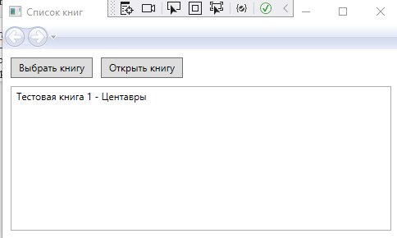
Рисунок 3 - пример работы программы

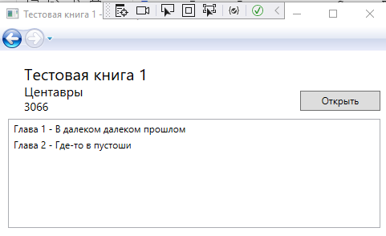
Рисунок 4 - пример работы программы

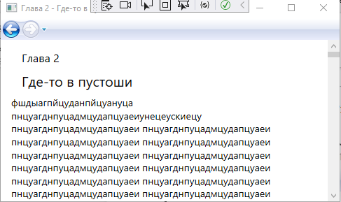
Рисунок 5 - пример работы программы

Вывод: В ходе лабораторной работы, были получены навыки в создании wpf приложения, с испльзованием страниц.

